Lauren Lawless

IST 659

June 23, 2019

Bird Boxes Database

Part II

Summary

Each summer, the Audubon Society of Rhode Island collects data on inhabitants of hundreds of blue bird boxes at several wildlife refuges across the state (the Fisherville Brook Wildlife Refuge alone has 43 boxes total). The data is collected and submitted weekly (for 11 weeks) to the state chapter and includes information on the conditions of the visit (date, time, temperature, weather, etc.) and box usage (occupant parent species, number of eggs, hatchlings, fledglings, etc.). For personal gain, I also collected data on box locations in order to help map optimal trail paths and researched attributes of feather colors, egg colors, and nest materials common to each species to aide in identifying occupant species. Data was collected for several weeks in spreadsheet format, which makes analysis of reproductive success difficult. A relational database format would allow for easier access and translatability for data in aggregate and time-dependent summary.

Conceptual Model

(Figure 1)

Each box is in one of five fields and has a box number (field letter and counted number), a unique latitude and longitude combination, and a position in the ordered list along an optimized trail.

Boxes are observed each week for an occupant species (not uniquely identified individuals), number of eggs present, number of hatchlings present, number of hatchlings fledged (presumed to be equal to the number of hatchlings in the box the previous week minus the number of hatchlings in the box in the current week), and any notes on miscellaneous conditions of the box.

A set of box observations takes place under one set of conditions (date, start time, end time, weather, temperature; one observation per box per observation set). Observation dates are unique.

Occupant birds are identified from a list of eight species that are common to New England in the summertime and for which the bird boxes provide suitable housing. Each species has a taxonomic Order, Family, Class, and Species (the last two compose the species name), common name, and shortened species code. Attributes that are species specific and may be helpful in identifying box occupants are feather colors, notable nesting materials, egg colors, typical clutch size range, incubation days range, hatched days range, and broods per year. We also note habitat preference, feeding behavior, and conservation status.

Normalized Logical Model

(Figure 2)

Primary keys will be automatically generated as int identity data types to maintain data integrity when identifiers might change. The multivalued attributes (weather conditions, observation notes, feather colors and patterns, nest materials, and egg colors and patterns) have been moved to their own entities with associative entities linking them to the original entities. The attribute Sex char(1) was added to the BirdBodyColorPattern entity because male and female birds of the same species will often have different color patterns. The compound attribute for box location was expanded into Latitude and Longitude, which are dependently unique.

Physical Database Design

See section “Code Segments” below for table creation, data maintenance and stored procedures, data load (from imported data tables), and test cases for stored procedures.

Data Creation and Manipulation

This database model will rely primarily on stored procedures for data entry, aside from the initial load of data from Microsoft Excel. All procedures are described below, and both successful and unsuccessful test cases given.

Implementation

(Figures 3, 4, 5, 6, and 7)

The user interface platform of choice was Tableau, as data entry will be handled by stored procedures and detailed reporting by Views. Tableau will help users see trends in the nesting and reproductive behaviors of the birds using the boxes, without having to process large tables of information with no emphasis on important figures.

Reflection

Moving into the physical, internal, and external phases of database development, I realized how grateful I was to have done the work of the conceptual and logical phases, because I understood the needs of the model through and through. I revisited the diagrams consistently, repeatedly moving things around and reconsidering how I would define the data and organize it.

Going through the entire process has informed my understanding of the balance between optimizing how data is stored and accessed by a machine and how it can be used and maintained by a human. I have noticed flaws in the database structure in my work life, which is quite unfortunate, since I do not have the authority to make changes.

Having built a system that would rely heavily on stored procedures for data entry by non-owners (i.e., anyone but myself), I recognize the importance of having a robust user interface to minimize opportunities for data flaws and invalid actions.

One of the most helpful aspects of implementing the database is something I learned in an undergraduate intro to computer programming course: writing robust test cases for procedures, queries, and other code, and anticipating the expected result before running the operation in order to highlight shortcomings in code, even when it processes without error.

Table 1 – Attribute Glossary

|  |  |  |  |
| --- | --- | --- | --- |
| Entity | Attribute | Properties | Example |
| Box | Box Number | Required, unique. | B3 |
| Field | Required. | B |
| Coordinates | Composite, required, unique. Made up of latitude and longitude values with four decimal places. | (41.5854, -71.5747) |
| Trail Order | Required, unique. | 10 |
| Observation | Number of Eggs | Required. | 0 |
| Number of Hatchlings | Required. | 2 |
| Number of Fledglings | Required. | 4 |
| Notes | May be multivalued. | Mom in box |
| Occupant Bird | Required, unique. | TRSW |
| Bird | Common Name | Required, unique. | Tree Swallow |
| Bird Code | Required, unique. | TRSW |
| Species Name | Required, unique. | Tachycineta bicolor |
| Taxonomic Order | Required. | Passeriformes |
| Taxonomic Family | Required. | Hirundinidae |
| Habitat |  | Lakes and ponds |
| Nesting Habit |  | Cavity |
| Feeding Behavior |  | Aerial forager |
| Conservation Status |  | Climate threatened |
| Clutch Size | Range of values. | 4-7 |
| Incubation Days | Range of values. | 14-15 |
| Hatched Days | Range of values. | 18-22 |
| Broods Per Year | Range of values. | 1-2 |
| Feather Color | Multivalued. | Male: iridescent blue, dark gray wings, white belly; Female: gray, dark gray wings, white belly |
| Nest Material | Multivalued. | dry grass lined with feathers |
| Egg Color | Multivalued. | white |
| Condition | Start Date Time | Required. | 06/17/2018 14:33:00 |
| End Date Time | Required. | 06/17/2018 16:35:00 |
| Temperature | Required. Measured at start of observations in degrees Fahrenheit. | 84 |
| Weather | Multivalued. | sunny |

Code Segments

Creating Tables

See File: “Birds Table Creation.sql”

* Checks for existence of all tables and drops them if they exist then rebuilds everything in order of foreign key requirements
* Table: Box
  + All fields required.
  + BoxNumber must be unique.
  + Latitude, Longitude combination must be unique – each box requires a distinct location. In terms of business rules, birds will not nest in boxes too close to other occupied boxes, especially when occupants are of the same species.
  + TrailOrder must be unique – box visits are sequential; an observer could not have two boxes be the *n*th box visited.
  + The first character in BoxNumber must be the same as Field.
* Table: Condition
  + All fields required.
  + StartDateTime and EndDateTime must be unique – conditions are recorded as constant for duration of visit and only one record per visit is necessary.
  + StartDateTime must be less than (“before”) EndDateTime.
  + StartDateTime and EndDateTime must occur on the same date.
* Table: Bird
  + Bird names and taxonomy fields required.
  + Fields with range values converted to two fields each, one for low value, one for high value. If a single-value estimate exists instead of a range, the estimate appears as the low value and the high value is NULL.
  + BirdCode, CommonName, and ScientificName must be independently unique.
* Table: Note
  + NoteText must be unique.
* Table: Weather
  + WeatherDescription must be unique.
* Table: BodyPattern
  + BodyPatternDescription must be unique.
* Table: Color
  + ColorDescription must be unity
* Table: EggPattern
  + EggPattern must be unique.
* Table: NestMaterial
  + NestMaterial must be unique.
* Table: Observation
  + BoxID and ConditionID are required.
  + NumberEggs, NumberHatched, and NumberFledged default to 0.
  + BoxID is a foreign key to BoxID in Box.
  + OccupantID is a foreign key to BirdID in Bird.
  + ConditionID is a foreign key to ConditionID in Condition.
* Table: ObservationNote
  + An associative table between Observation and Note.
  + Each row must be unique.
* Table: WeatherCondition
  + An associative table between Condition and Weather.
  + Each row must be unique.
* Table: BirdBodyColorPattern
  + An associative table between Bird and Color and between Bird and BodyPattern.
  + Sex identifies whether the Color, BodyPattern combination belongs to the female or male of the species.
  + Each row must be unique.
* Table: BirdEggColorPattern
  + An associative table between Bird and Color and between Bird and EggPattern.
  + Each row must be unique.
* Table: BirdNestMaterial
  + An associative table between Bird and NestMaterial.
  + Each row must be unique.



Data Maintenance and Stored Procedures

See File: “Birds Data Maintenance and Stored Procedures.sql”

See File: “Birds Data Load.sql”

See File: “Bird TEST Cases.sql”

* Checks for existence of all procedure and drops them if they exist then rebuilds everything.
* Procedure: AddBirdBasic – inserts required attributes into Bird
  + Accepts BirdCode, CommonName, ScientificName, TaxonomicOrder, TaxonomicFamily.
  + Checks existence in Bird of BirdCode, CommonName, ScientificName.
    - If yes, error.
    - If no, continue.
  + Inserts BirdCode, CommonName, ScientificName, TaxonomicOrder, TaxonomicFamily into Bird.



* Procedure: AddBirdLong – inserts all attributes into Bird
  + Accepts a value for each attribute in Bird.
  + Checks existence in Bird of BirdCode, CommonName, ScientificName.
    - If yes, error.
    - If no, continue.
  + Inserts all attributes into Bird.
  + Values can be NULL, but all values must be specified in execution.



* Procedure: AddBirdExtras – updates non-required attributes in Bird
  + Accepts BirdCode and all non-required attributes in Bird.
  + Checks existence in Bird of BirdCode.
    - If yes, continue.
    - If no, error.
  + Updates the row in Bird of given BirdCode.
    - If the given value is NULL, checks for existing non-NULL value.
      * If non-NULL value exists, it is not overwritten with NULL.
    - If given value is non-NULL, updates attribute.



* Procedure: AddBirdBodyColorCombination – inserts body color and pattern combinations into BirdBodyColorPattern
  + Accepts BirdCode, Sex, Color, and BodyPattern.
  + Checks that Sex is either “F” or “M”.
    - If yes, continue.
    - If no, error.
  + Checks existence in Bird of BirdCode.
    - If yes, continue.
    - If no, error.
  + Checks existence in Color of Color.
    - If yes, continue.
    - If no, inserts Color into Color and continue.
  + Checks existence in BodyPattern of BodyPattern.
    - If yes, continue.
    - If no, inserts BodyPattern into BodyPattern and continue.
  + Checks existence in BirdBodyColorPattern of BirdCode, Sex, Color, BodyPattern combination.
    - If yes, error.
    - If no, inserts BirdCode, Sex, Color, BodyPattern combination into BirdBodyColorPattern.



* Procedure: AddBirdEggColorCombination – inserts egg color and pattern combinations into BirdEggColorPattern
  + Accepts BirdCode, Color, and EggPattern.
  + Checks existence in Bird of BirdCode.
    - If yes, continue.
    - If no, error.
  + Checks existence in Color of Color.
    - If yes, continue.
    - If no, inserts Color into Color and continue.
  + Checks existence in EggPattern of EggPattern.
    - If yes, continue.
    - If no, inserts EggPattern into EggPattern and continue.
  + Checks existence in BirdBodyColorPattern of BirdCode, Color, EggPattern combination.
    - If yes, error.
    - If no, inserts BirdCode, Color, EggPattern combination into BirdEggColorPattern.
* Procedure: AddBirdNestMaterialCombination – inserts nest materials into BirdNestMaterial
  + Accepts BirdCode and NestMaterial.
  + Checks existence in Bird of BirdCode.
    - If yes, continue.
    - If no, error.
  + Checks existence in NestMaterial of NestMaterial.
    - If yes, continue.
    - If no, inserts NestMaterial into NestMaterial and continue.
  + Checks existence in BirdNestMaterial of BirdCode, NestMaterial combination.
    - If yes, error.
    - If no, inserts BirdCode, NestMaterial combination into BirdNestMaterial.
* Procedure: AddBox – inserts new box into Box
  + Accepts all attributes of Box except Field, which is derived from BoxNumber.
  + Checks existence in Box of BoxNumber or Latitude, Longitude combination.
    - If yes, error.
    - If no, continue.
  + Updates TrailOrder of all rows in Box where TrailOrder is greater than or equal to (“after”) given TrailOrder for new box with the previous value +1.
  + Inserts BoxNumber, derived Field, Latitude, Longitude, TrailOrder into Box.



* Procedure: DeleteBox – deletes a box from Box
  + Accepts BoxNumber.
  + Checks existence in Box of BoxNumber.
    - If yes, continue.
    - If no, error.
  + Deletes row from Box with matching BoxNumber.
  + Updates TrailOrder of all rows in Box where TrailOrder is greater than TrailOrder of deleted box with the previous value -1.

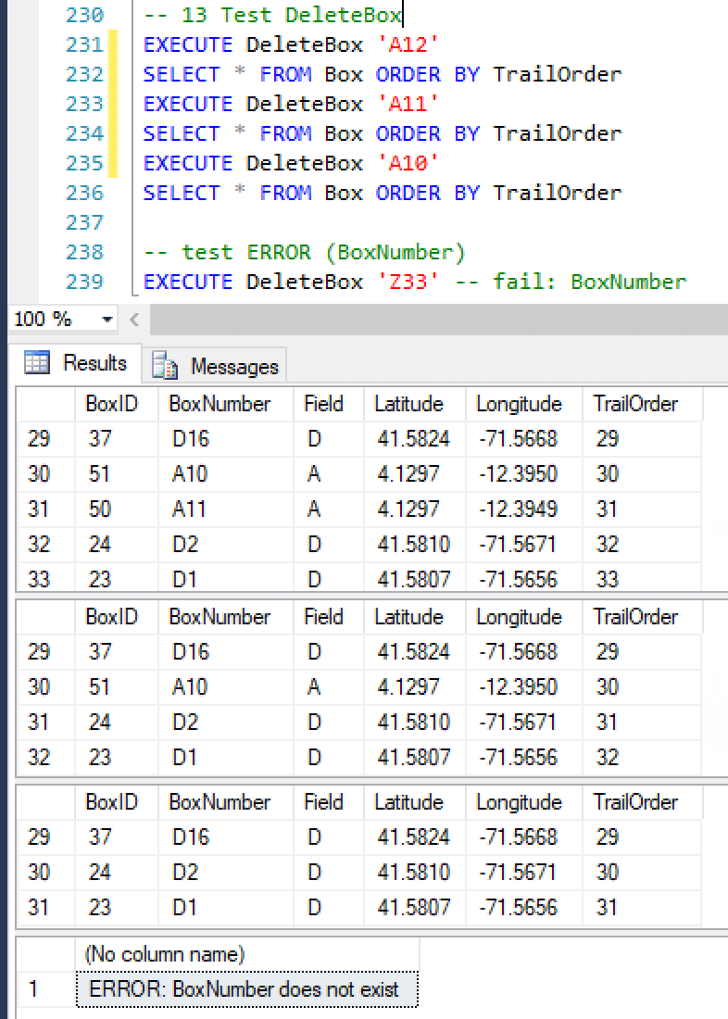

* Procedure: AddCondition – inserts new visit condition
  + Accepts Year, Month, Date, StartTime, EndTime (all strings), and Temperature.
  + Converts date piece strings into StartDateTime and StartEndTime.
  + Checks that StartDateTime is less than (before) EndDateTime.
    - If yes, continue.
    - If no, error.
  + Checks existence in Condition of StartDateTime or EndDateTime.
    - If yes, error.
    - If no, continue.
  + Inserts StartDateTime, EndDateTime, Temperature into Condition.



* Procedure: AddWeatherCondition – inserts record into WeatherCondition
  + Accepts Date and Weather.
  + Checks existence in Condition of a datepart of StartDateTime equal to Date.
    - If yes, continue.
    - If no, error.
  + Checks existence in Weather of Weather.
    - If yes, continue.
    - If no, inserts Weather into Weather and continue.
  + Checks existence in WeatherCondition of Condition, Weather combination.
    - If yes, error.
    - If no, continue.
  + Inserts Condition, Weather combination into WeatherCondition.
* Procedure: AddObservation – inserts observation into Observation
  + Accepts Date, BoxNumber, OccupantCode, NumberEggs, NumberHatched, NumberFledged.
  + Checks existence in Box of BoxNumber.
    - If yes, continue.
    - If no, error.
  + Checks existence in Condition of a datepart of StartDateTime equal to Date.
    - If yes, continue.
    - If not, error.
  + Checks existence in Observation of BoxNumber, Date combination.
    - If yes, error.
    - If no, continue.
  + Checks existence in Bird of BirdCode.
    - If yes, continue.
    - If no, error.
  + Inserts BoxNumber, OccupantCode, NumberEggs, NumberHatched, NumberFledged, and Date into Observation.



* Procedure: AddObservationNote – inserts record into ObservationNote
  + Accepts Date, BoxNumber, and Note.
  + Checks existence in Box of BoxNumber.
    - If yes, continue.
    - If no, error.
  + Checks existence in Condition of a datepart of StartDateTime equal to Date.
    - If yes, continue.
    - If no, error.
  + Checks existence in Note of Note.
    - If yes, continue.
    - If no, inserts Note into Note and continue.
  + Checks existence in ObservationNote of Observation, Note combination.
    - If yes, error.
    - If no, continue.
  + Inserts Observation, Note combination into ObservationNote.

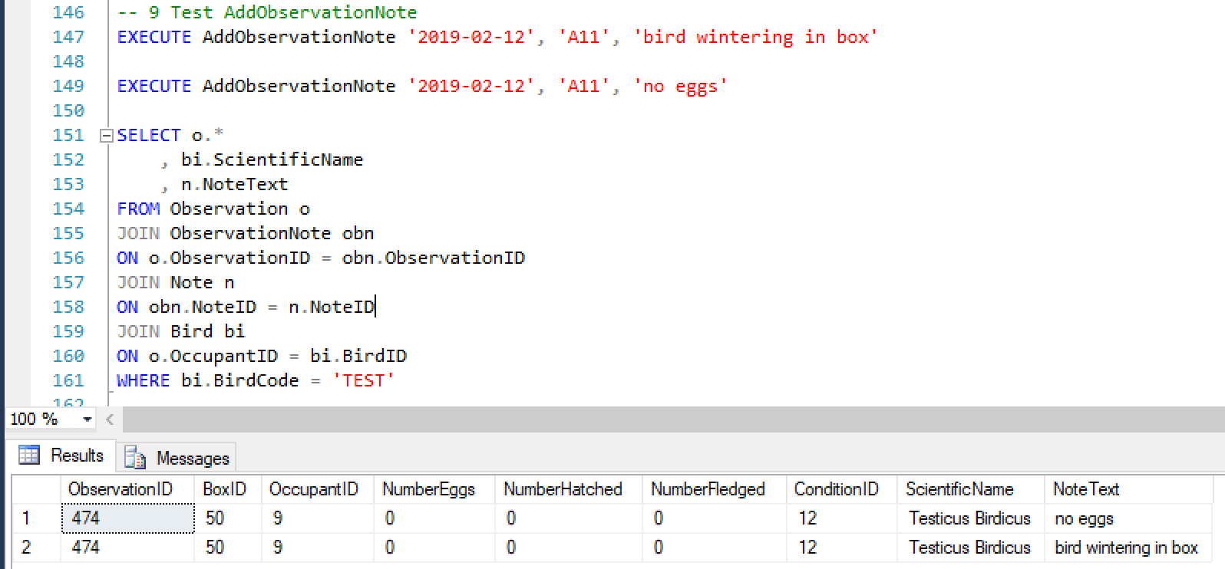

Figure 1 – Conceptual Model

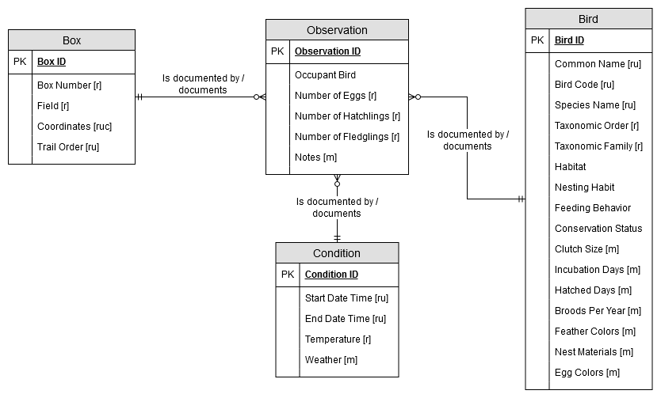

Figure 2 – Normalized Logical Model

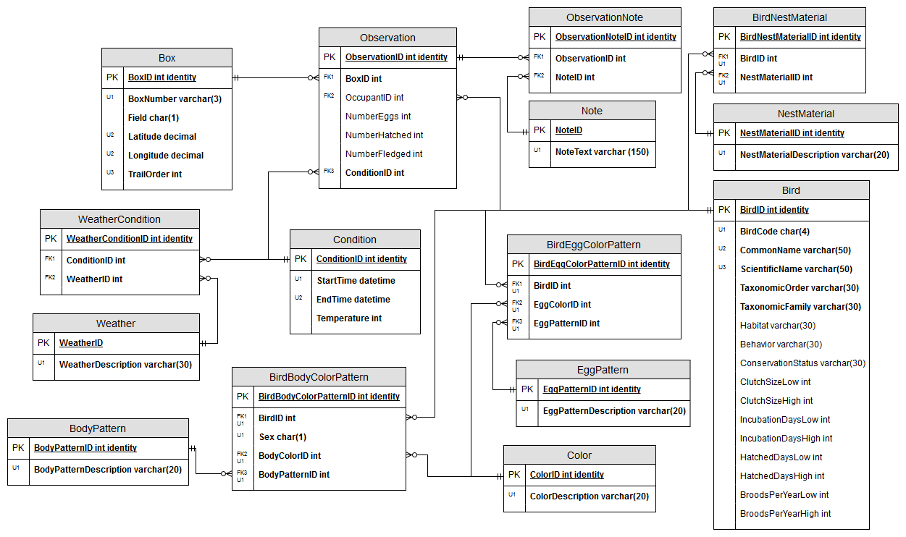

Figure 3 – User Interface, Observations (Tableau)

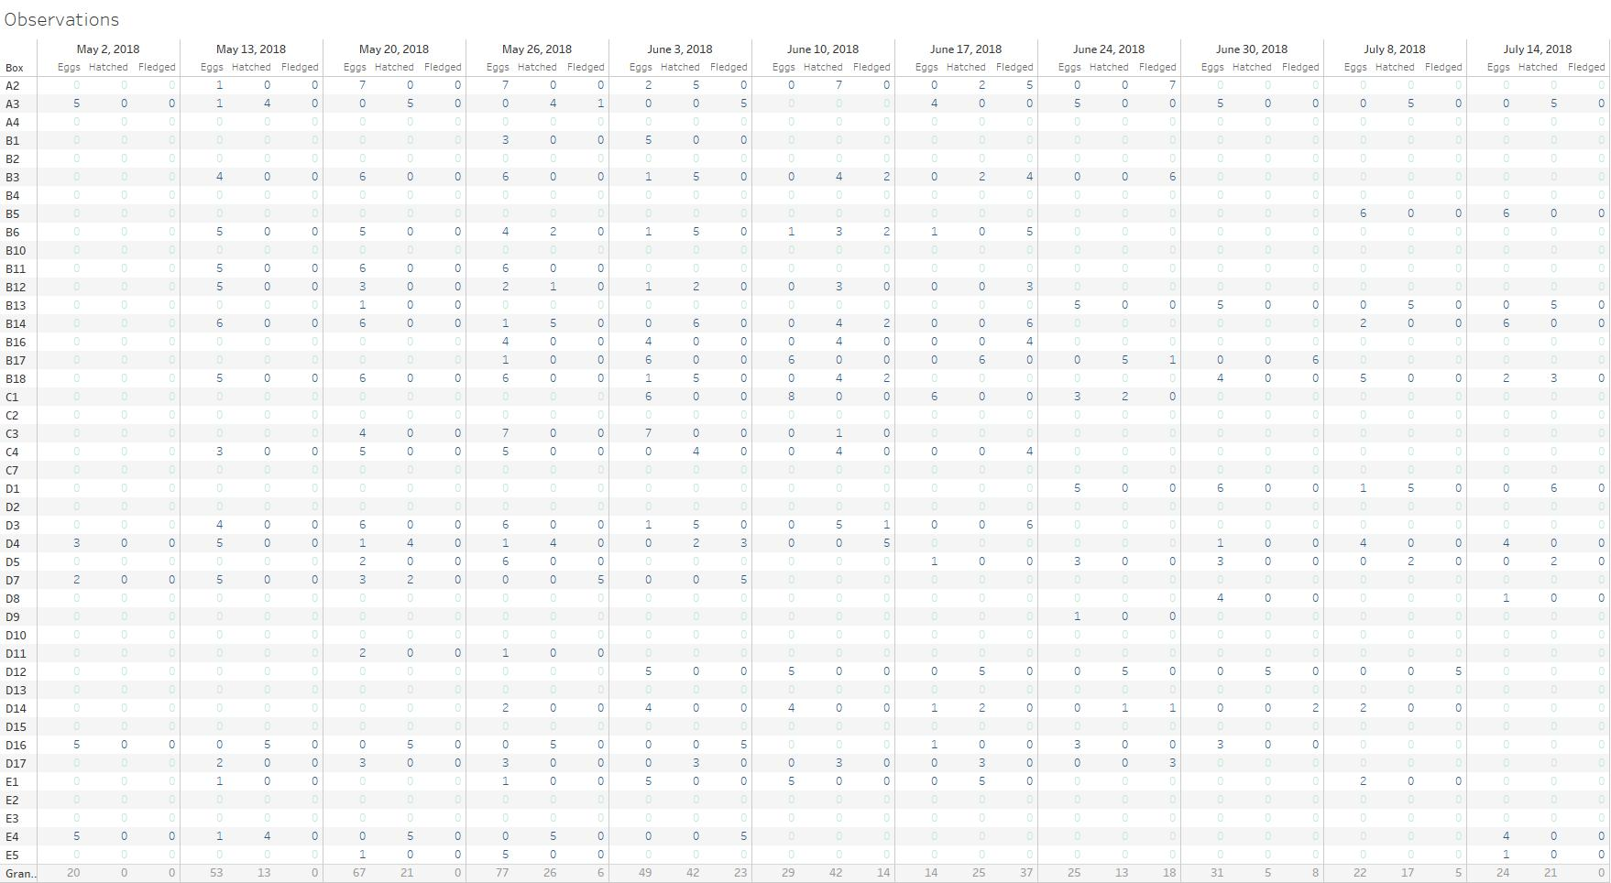

Figure 4 – User Interface, Trail Order (Tableau)

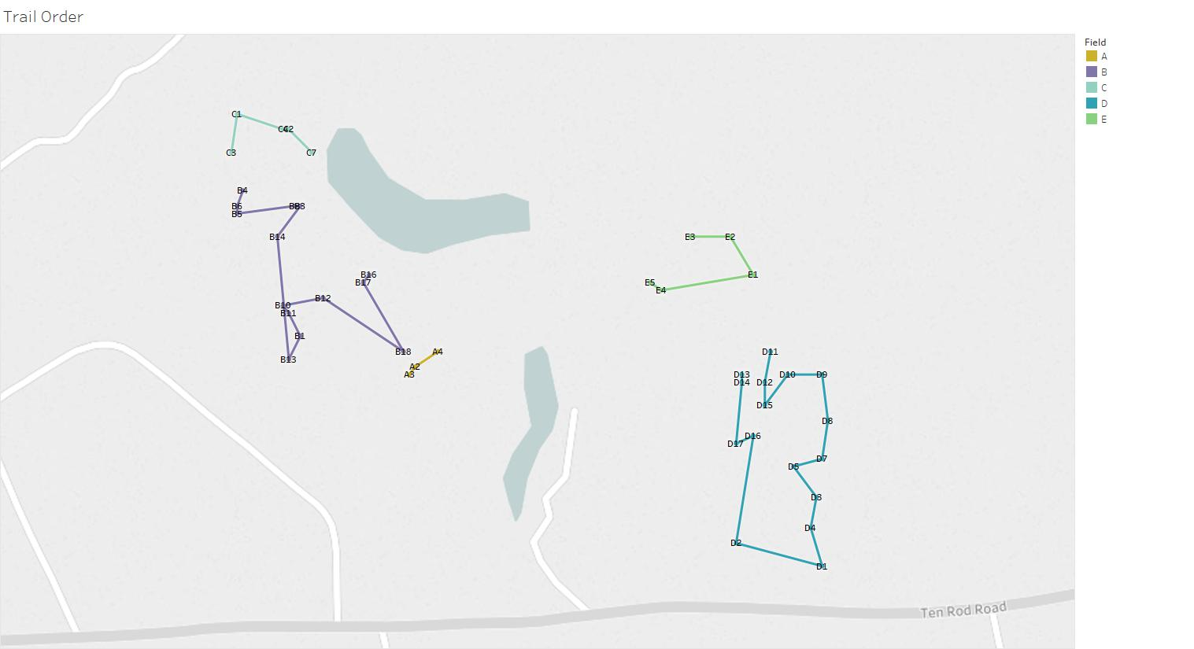

Figure 5 – User Interface, Stages of Development (Tableau)

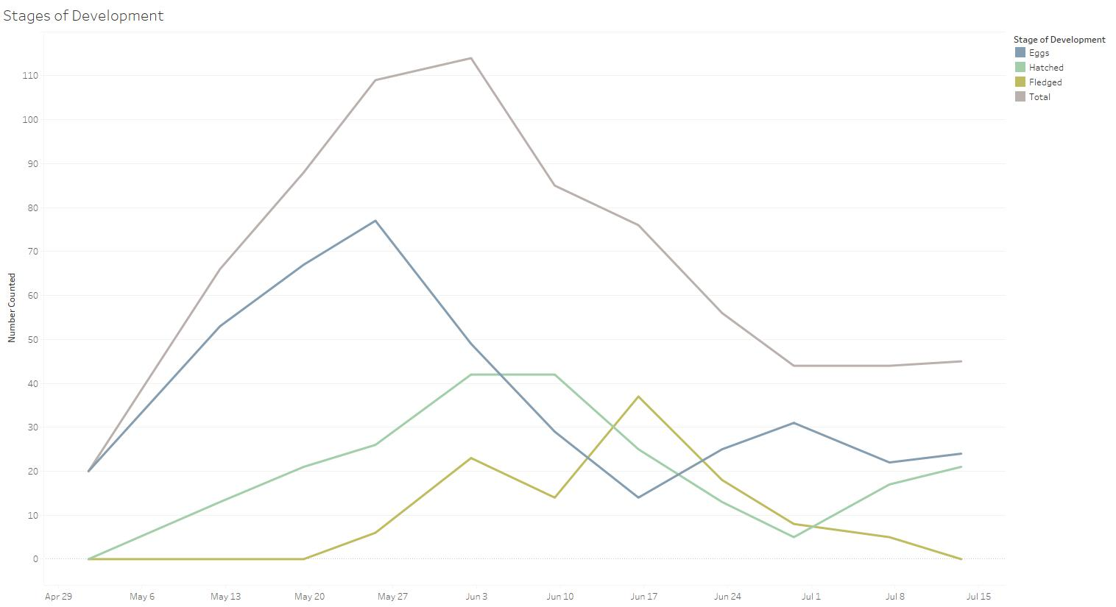

Figure 6 – User Interface, Nesting Period (Tableau)

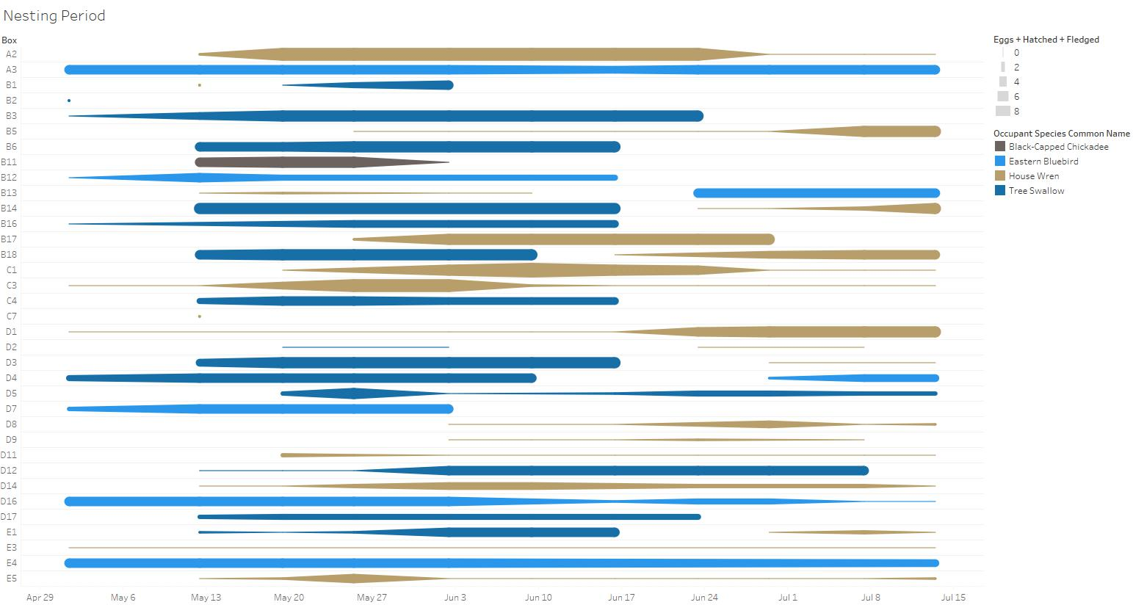

Figure 7 – User Interface, Nest Dispersion June 3, 2018 (Tableau)